ACTIVITY 1
- What is your initial reaction to the suitability of each potential couch surfer? Identify the people you would accept as a couch surfer.
  A | B |   C |  |   D |   E |  |   F
YES/NO | YES/NO | YES/NO |  | YES/NO | YES/NO |  | YES/NO
  G |   H |   I | J |  |   K |   L
YES/NO | YES/NO | YES/NO | YES/NO |  | YES/NO | YES/NO

- What is your initial reaction to each couch in terms of its suitability for couch surfing? Identify the couches on which you would like to couch surf.
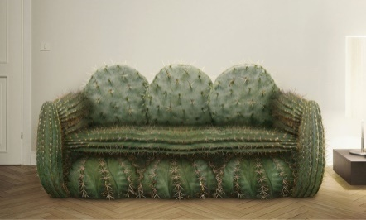  A | 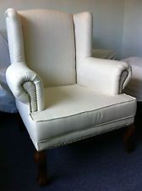  B | 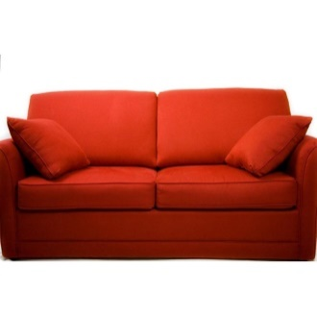  C | 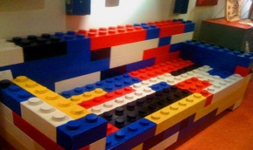  D
YES/NO | YES/NO | YES/NO | YES/NO
  E |   F |   G | 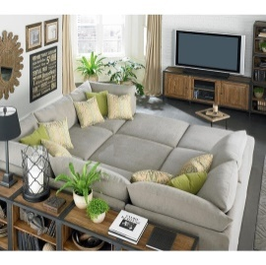  H
YES/NO | YES/NO | YES/NO | YES/NO

- For each potential couch surfer, which factor was most influential in determining whether you would accept or reject them?
  - their physical characteristics ____________________________
  - their (assumed) emotional characteristics ___________________________
  - the initial feelings they evoke in you ____________________________

- For each potential couch, which factor was most influential in determining whether you would couch surf or not?
  - its aesthetic features __________________________________
  - its (assumed) functionality __________________________________
  - the initial feelings it evokes in you _____________________________________

